**PROGRAMS:**

1. **Define a class named “fraction” whose objects represent rational numbers. Include integer data members num and den for storing numerator and denominator respectively.**

**Also include following:**

1. **Default constructor**
2. **Parametrised constructor with 2 arguments.**
3. **Copy constructor**
4. **Function eval_func() for evaluating the rational number**
5. **Friend function display() for displaying the fraction in the form num/den**

**Input:**

#include<iostream>

#include<conio.h>

using namespace std;

class fraction {

int num;

int den;

public:

fraction() {

num = den = 1;

}

fraction(int n, int d) {

num = n;

den = d;

}

fraction(fraction &obj) {

num = obj.num;

den = obj.den;

}

void eval_func() {

double result;

if (num == den) {

result = 1;

}

else if (den == 0) {

cout << "Invalid denominator" << endl;

result = num;

return;

}

else {

result = (double)num / den;

}

cout << "The result of the evaluation is " << result <<endl;

}

friend void display(fraction &obj);

};

void display(fraction& obj) {

cout <<"Result: "<<obj.num << "/" << obj.den << endl;

}

int main() {

int n, d;

cout << "Calling Default Constructor" << endl;

fraction obj;

display(obj);

cout << "Calling Parameterised Constructor" << endl;

cout << "Enter numerator and denominator :";

cin >> n >> d;

fraction obj2(n,d);

obj2.eval_func();

display(obj2);

cout << "Calling Copy Constructor" << endl;

fraction obj3(obj2);

display(obj3);

_getch();

return 0;

}

**Output:**

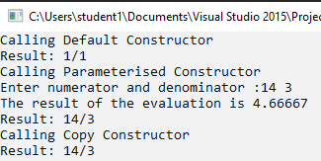

1. **Write a program to implement a banking system with data members balance and rate of interest.**

**Also include following:**

1. **Constructor to initialise the data members**
2. **Copy constructor**
3. **Make a deposit**
4. **Withdraw an amount**
5. **Calculate interest.**
6. **Destroy object using destructor.**

**Input:**

#include<iostream>

#include<conio.h>

#include<string>

using namespace std;

class BankAccount {

string name;

double balance;

public:

BankAccount() {

cout << "Enter the name of the account holder: ";

cin >> name;

balance = 0;

}

BankAccount(BankAccount &obj) {

name = obj.name;

balance = obj.balance;

}

void deposit(int amount) {

balance += amount;

cout << "Deposited : " << amount << endl;

cout << "Total Balance: " << balance << endl;

return;

}

void withdraw(int amount) {

balance -= amount;

cout << "Withdrawn : " << amount << endl;

cout << "Total Balance: " << balance << endl;

return;

}

void calculate_interest(float interestRate, int years) {

double interest = 0.0;

interest = (balance * interestRate * years) / 100;

cout << "Interest amount : " << interest << endl;

return;

}

~BankAccount() {

cout << "destructor called";

}

friend void display(BankAccount&);

};

void display(BankAccount& obj) {

cout << "Namr : " << obj.name << endl;

cout << "Total Balance: " << obj.balance << endl;

}

int main() {

BankAccount customer1;

BankAccount customer2(customer1);

customer1.deposit(1000);

customer1.withdraw(500);

customer1.calculate_interest(4.2, 2);

cout << "Object 1 " << endl;

display(customer1);

cout << "Object 2" << endl;

display(customer2);

_getch();

return 0;

}

**Output:**

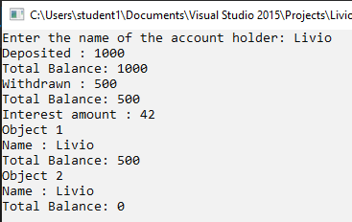

1. **Show the use of constructor with default arguments**

**Define a class named “box” with integer data members l, b, h. Use constructors with default arguments to initialize the variables.**

**Input:**

#include<iostream>

#include<conio.h>

using namespace std;

class box {

float l, b, h;

public:

box(float argL = 3.6, float argB = 4.8, float argH = 6.3) {

l = argL;

b = argB;

h = argH;

}

void display() {

cout << "Lenght: " << l << " Breadth: " << b << " Height: " << h << endl;

}

};

int main() {

float l, b, h;

cout << "Enter Lenght, Breadth & Height :";

cin >> l >> b >> h;

box cube;

cout << "Without passing args" << endl;

cube.display();

box cuboid(l,b,h);

cout << "Passing args" << endl;

cuboid.display();

_getch();

return 0;

}

**Output:**

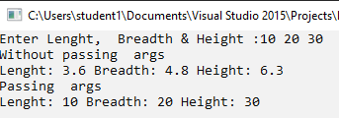

1. **Write a C++ Program to Overload parameterised Constructor.**

**Input:**

#include<iostream>

#include<conio.h>

#include<string>

using namespace std;

class box {

float length, breadth, height, volume;

public:

box(float length)

{

volume = length*length*length;

}

box(float length, float breadth, float height)

{

volume = length*breadth*height;

}

void display() {

cout << "Volume : " << volume<<endl;

}

};

int main() {

float s, length, breadth, height, totalVolume;

cout << "Enter the Length of cube : ";

cin >> length;

box cube(length);

cube.display();

cout << "Enter the Length, breadth & height: ";

cin >> length >> breadth >> height;

box cuboid(length, breadth, height);

cuboid.display();

_getch();

return 0;

}

**Output:**

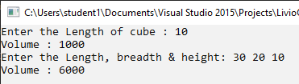

1. **Write a C++ program to join two strings using classes. Make use of dynamic Memory Allocation.**

**Program:**

#include <iostream>

#include <conio.h>

#include <string.h>

using namespace std;

class Strings

{

char *str = new char;

public:

void getStr(){

cin >> str;

}

void concat(Strings b){

strcat_s(str, b.str);

cout << str;

}

};

int main(){

Strings str1, str2;

cout << "Enter First string: ";

str1.getStr();

cout << "Enter Second string: ";

str2.getStr();

cout << "Concatenated string is: ";

str1.concat(str2);

return 0;

**}**

**Output:**

